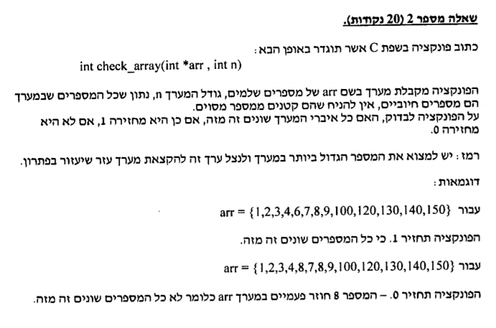

int check_array(int *arr, int n)

{

int i,j;

for (i = 0; i < n; i++)

{

for (j = i+1; j < n; j++)//there is no need to check location i and before it

{

if (arr[i] == arr[j])

return 0;

}

}

return 1;

}

void main()

{

int arr[N] = { 1,2,3,4,6,7,8,9,6,120,130,140,150};

if (check_array(arr, N)==1)

printf("ok\n");

else

printf("not ok\n");

}